STATE OF WISCONSIN
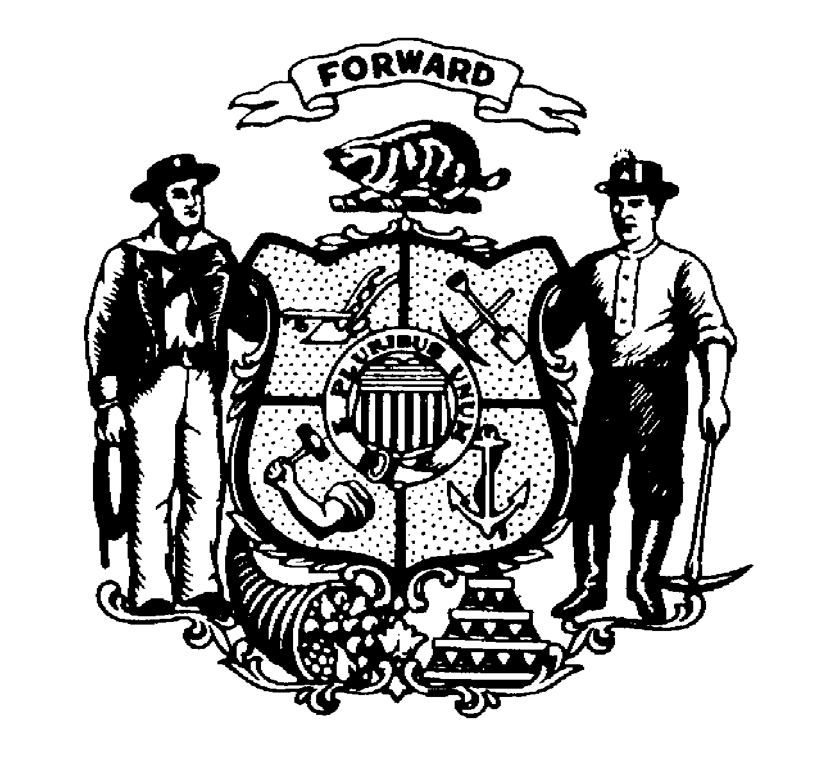
DEPARTMENT OF JUSTICE

VOCA Volunteer Waiver Request

Subgrant Number: ____________________________ Agency Name: ________________________________

In order to be eligible to receive VOCA funds, agencies must use volunteers to provide direct services. An agency may use volunteers that provide direct services outside of the VOCA project to fulfill this requirement. OCVS “may waive this requirement, provided that the [applicant agency] submits written documentation of its efforts to recruit and maintain volunteers, or otherwise demonstrate why circumstances prohibit the use of volunteers.”

If the organization does not utilize volunteers in any capacity to provide direct victim services, a waiver of the federal volunteer requirement must be requested. To request this waiver, please choose from the following;

( ) The organization is unable to recruit and maintain volunteers after an aggressive effort. Provide an explanation below documenting all efforts to recruit volunteers and attach additional pages and/or supporting documentation if necessary.

( ) Organization can demonstrate why circumstances prohibit the use of volunteers.

If the organization plans to use volunteers in the future, explain the recruitment efforts and what activities the volunteers would be performing. Attach additional pages if necessary.

___________________________________________ __________________________________________
Name of Authorized Official or Project Director Title/Position

___________________________________________ ________________
Signature of Authorized Official or Project Director Date

( ) Waiver Approved

( ) Waiver Denied

___________________________________________ __________________________________________
Cindy Grady, Director of Grant Programs & Operations Date
Wisconsin Department of Justice, Office of Crime Victim Services

