DNE
STATE OF WISCONSIN
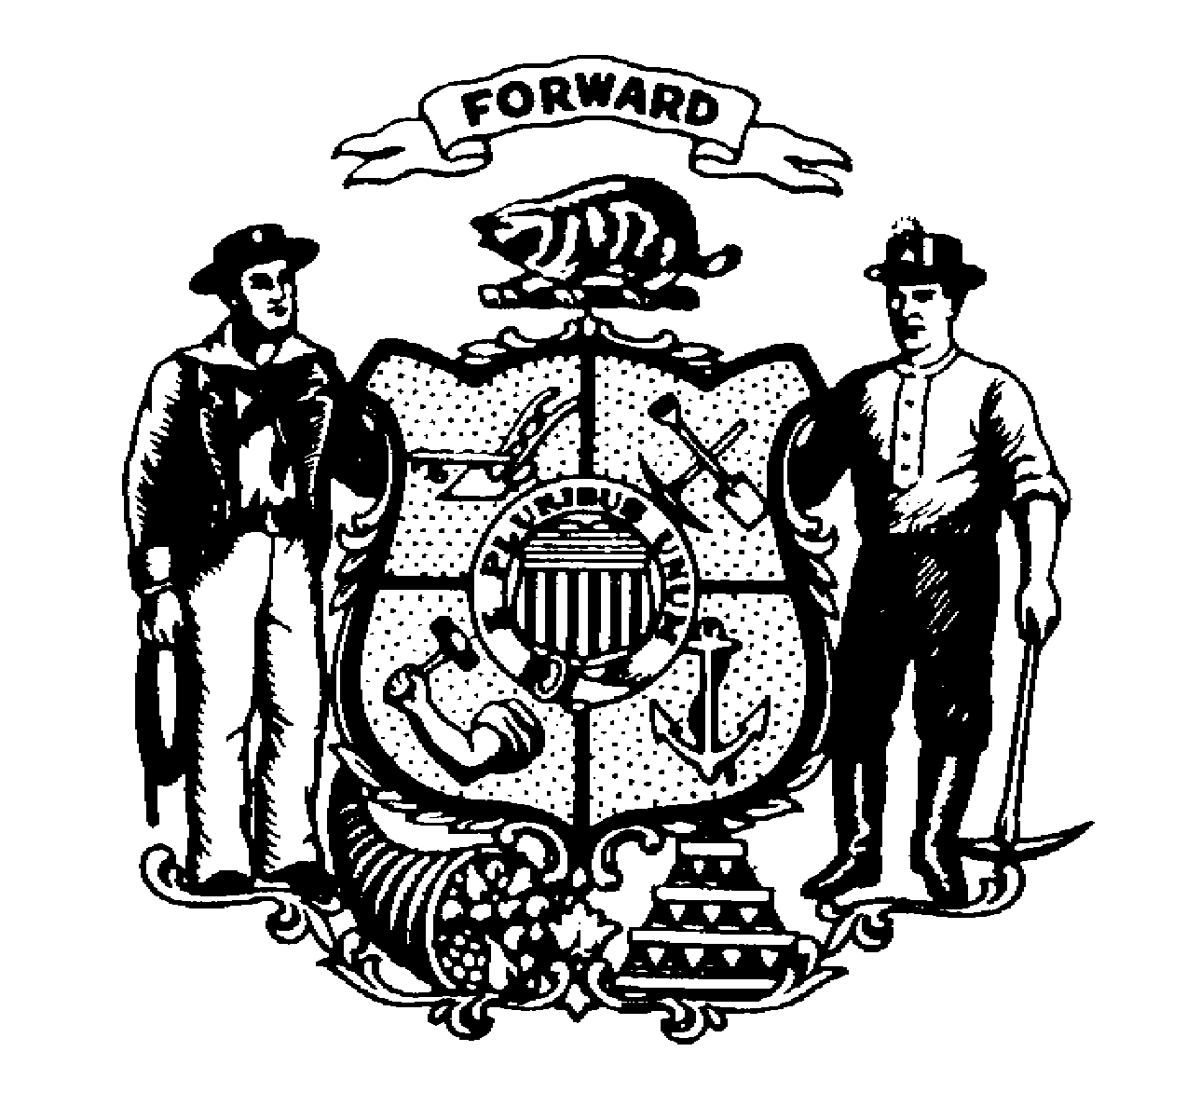
DEPARTMENT OF JUSTICE
⎯⎯⎯⎯⎯⎯⎯⎯⎯⎯⎯⎯⎯⎯⎯⎯⎯⎯⎯⎯⎯⎯⎯⎯⎯⎯⎯⎯⎯⎯⎯⎯⎯⎯⎯⎯⎯⎯⎯⎯⎯⎯⎯⎯⎯
Josh Kaul  Attorney General |  | Michelle Viste, Executive Director  Office of Crime Victim Services  17 West Main Street  P.O. Box 7951  Madison, WI 53707-7951  (608)264-9497  (608)264-6368 FAX  (800)947-3529 TTY

Certification to Apply 10% De Minimus Indirect Cost Rate

The Wisconsin Department of Justice Office of Crime Victim Services (OCVS) requires certification of the 10% de minimus indirect cost rate before approval of the grant budget.

Specifically the applicant agency affirms it has never received a NICRA (a federally negotiated indirect cost rate agreement) and therefore is eligible to receive the de minimus rate.

This methodology once elected must be used consistently for all Federal awards until such time as the agency chooses to negotiate a rate, and costs will be consistently charged as either indirect or direct costs.

Authorized Signing Official: By requesting the 10% de minimus indirect cost rate, I certify that the applicant agency complies with the terms of its use as set forth in the Uniform Guidance, Title 2 of the Code of Federal Regulation §200.414.

*The Authorized Signing Official should be the same as the identified Signing Official in the VOCA grant application submitted in Egrants.

Signature of Authorized Official  (Board Chair, Co. Executive, Mayor) |  | Date
Applicant Agency

