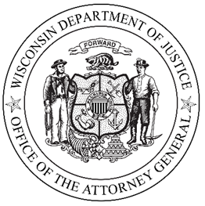

NEWS FOR IMMEDIATE RELEASE

May 24, 2019

Jury Convicts Two Ashland County Men of First-Degree Intentional Homicide

MADISON, Wis. – On May 22, 2019, Brian Sweet, age 41, and Brian Matthew Nelis, age 41, were found guilty by a jury of first-degree intentional homicide while armed as a party to a crime for the killing of Shane Cadott. The trial was presided over by Iron County Judge Patrick Madden.

“Thanks to the hard work of the Ashland County Sheriff’s Office, the Wisconsin State Crime Lab, and DOJ’s Criminal Litigation Unit, justice has been served for this terrible crime,” said Attorney General Kaul.

The evidence presented at trial established that in the early morning hours of September 23, 2017, Sweet and Nelis killed Cadott. Cadott’s body was found with multiple stab wounds, incise wounds and blunt force trauma in a secluded area on the Bad River Reservation in Ashland, Wisconsin on September 28, 2017.

The conviction was obtained through the work of the Wisconsin Department of Justice (DOJ) Division of Forensic Science, namely, DNA analyst Denise Jones, fingerprint examiner Stacy Gordon, and imaging expert Brooke Laxton, trace evidence examiner Raymond Lenz, as well as the extensive and through investigation conducted by the Ashland County Sheriff’s Department, and the Dane County Chief Medical Examiner Vincent Trancida. The prosecution of this case has been handled by Assistant Attorney General Christopher Liegel of the DOJ Criminal Litigation Unit.

Sentencing has not been scheduled. Both Sweet and Nelis face a mandatory life sentence.

