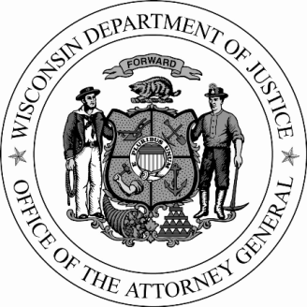
P.O. Box 7857
Madison, WI 53707-7857
www.doj.state.wi.us

BRAD D. SCHIMEL
ATTORNEY GENERAL
NEWS RELEASE

DOJ PRESCRIPTION DRUG TAKE BACK DAY COMING OCTOBER 17

October 8, 2015 Contact: Anne E. Schwartz 608-266-6686

The Wisconsin Department of Justice will coordinate a Prescription Drug Take Back initiative on Saturday, October 17, 2015 with municipalities and law enforcement statewide.
This effort will continue to bring focus to the issue of prescription opiate abuse highlighted by the Wisconsin Department of Justice’s Dose of Reality campaign to prevent prescription painkiller abuse. The goal of the Take Back Day is to provide a safe, convenient and responsible means of disposal, while also educating the community about the potential for abuse of these medications.
“With the opiate epidemic devastating families and communities across our state, we must work together to remove unused prescription painkillers from circulation. They need to be collected and destroyed,” Wisconsin Attorney General Brad Schimel said. “This program will also reduce the environmental hazards associated with the improper disposal of unused prescription drugs.”
Find a Take Back location near you at http://doseofrealitywi.gov/drug-takeback/find-a-take-back-location/ And please check out www.DoseofRealityWI.gov for more information on the importance of ridding your household of unused prescription medications.
Unused or expired medicine should never be flushed or poured down the drain. Water reclamation facilities are not designed to remove all of them and trace amounts of pharmaceuticals are showing up in rivers and lakes around the world.
GUIDELINES:

All waste pharmaceuticals must be generated by a household – no businesses are allowed.

Bring: Prescription (controlled and non-controlled) and over-the-counter medications, ointments, patches, non-aerosol sprays, creams, vials and pet medications.

Do Not Bring: Illegal drugs, needles/sharps, inhalers, aerosol cans, bio-hazardous materials (anything containing a bodily fluid or blood), personal care products (shampoo, soaps, lotions, sunscreen), household hazardous waste (paint, pesticides, oil, gas), mercury thermometers.

- more –
DOJ Drug Take Back Day
Page Two

- Participants may dispose of solid, non-liquid medication(s) by removing the medication from its container and disposing of it directly into a disposal box or into a clear sealable plastic bag. Plastic pill containers should not be collected. Blister packages are acceptable without the medications being removed.

- Liquids will be accepted during this initiative. However, the liquids, creams and sprays must be in their original packaging and evenly distributed within the boxes of collected solid prescription medications. Liquids without the original packaging will not be accepted.

- Illicit substances such as marijuana or methamphetamine are not a part of this initiative and should not be placed in collection containers.

# # #

