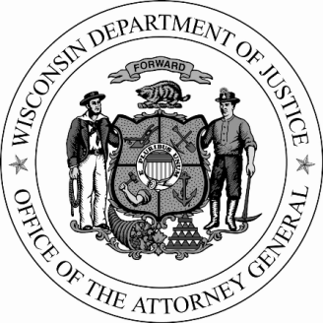
P.O. Box 7857
Madison, WI 53707-7857
www.doj.state.wi.us

BRAD D. SCHIMEL
ATTORNEY GENERAL

AG SCHIMEL NAMES NEW ASSISTANT ATTORNEYS GENERAL

September 1, 2015 Contact: Anne E. Schwartz (608) 266-6686

Attorney General Brad Schimel today administered the oath of office to five new assistant attorneys general. Included in the group is Paul Ferguson, who will lead the newly-created Office of Open Government at the Department of Justice. Following are brief bios for the newest additions to the Department of Justice staff.

Anzivino, Theresa M.
Anzivino is an assistant attorney general in the Civil Litigation Unit. She graduated cum laude from Marquette University Law School and holds a Bachelor of Science in both Legal Studies and Spanish from the University of Wisconsin. After graduating from law school, she clerked for Judge Pamela Pepper in the Bankruptcy Court for the Eastern District of Wisconsin. She also worked in private practice at DeWitt Ross & Stevens, S.C., focusing on general civil litigation and bankruptcy and insolvency-related cases.

Berg, Luke N.
Berg is an assistant attorney general in the Special Litigation and Appeals Unit. He studied computer science, math and philosophy at the University of Wisconsin and worked as a web developer and designer for four years before attending law school. Luke received his Juris Doctor, magna cum laude, from New York University. After law school, Berg clerked for Judge Diane S. Sykes on the Seventh Circuit Court of Appeals. He worked for the Office of the Comptroller of the Currency in Washington, D.C. immediately before joining DOJ.

Buttchen, Shannon A.
Buttchen joined the Civil Litigation Unit as an assistant attorney general. She earned her Juris Doctor from the University of Wisconsin Law School and has worked as an associate attorney in the private sector specializing in civil litigation.

Ferguson, Paul M.
Ferguson graduated magna cum laude from Seton Hall University in South Orange, New Jersey with a Bachelor of Arts in communication. While attending Seton Hall, Ferguson was a writer for the student newspaper, The Setonian, worked for the campus radio station and earned a certificate in television and video production. He earned his Juris Doctor from the University of Notre Dame Law School. During law school, Ferguson worked for the Supreme Court of

- more -
Schimel names new AAGs
Page Two

Pennsylvania, the Superior Court of Pennsylvania, the Office of the District Attorney of Cumberland County, Pennsylvania and the Office of the Public Defender in St. Joseph County, Indiana. Ferguson worked in private practice in Pennsylvania for eight years. Most recently, he worked on appellate issues before the U.S. Supreme Court and Wisconsin Supreme Court.

Rosenow, Scott E.
Rosenow joined the Division of Legal Services, Criminal Appeals Unit as an assistant attorney general. He previously held a fellowship at the Pacific Legal Foundation in California and clerked for Justice Annette Ziegler of the Wisconsin Supreme Court. Scott has a degree in political science and his Juris Doctor, both from the University of Wisconsin. He has a forthcoming publication about equal protection of the law in a journal produced by the University of Texas School of Law.
# # #

