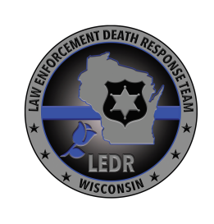

Wisconsin Law Enforcement Death Response (LEDR) Team

Assessment of Preparedness for Yourself and Your Family

- Have I taken all the necessary steps to prepare for the possibility of my death, to help ease the burden on my family (completed/updated LODD packet, completed/updated financial packet, Will, etc.)?

- Have I prepared my family for the possibility of my unexpected death?

- Have I communicated my wishes to my agency and my family, in the event I die in the line of duty (submitted LODD packet and financial packet to agency, location of Will, etc.)?

If you answered “no” to any of the above questions, contact a member of the LEDR Team to get more information about the steps you can take to prepare.

To contact a member of the LEDR Team:

- Visit https://www.doj.state.wi.us/dles/law-enforcement-death-response-team for the list of members and for additional information
- e-mail Chief Todd Thomas, LEDR Team Coordinator at todd.thomas@appleton.org

