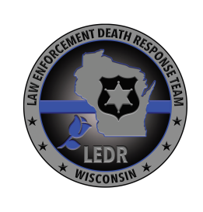

Wisconsin Law Enforcement Death Response (LEDR) Team

Assessment of Agency Preparedness

- Is my agency properly prepared to deal with the death of one of its active members?

- Does my agency have a current, written policy regarding line-of-duty deaths (LODD)?

- Does my agency require each of its members to submit a LODD packet, and update it?

- Does my agency understand the role and responsibilities of a family liaison?

- Are the members of my agency aware of the LEDR Team, and that the team is able to provide and coordinate resources, in the event of an active-duty death?

If you answered “no” to any of the above questions, please contact a member of the LEDR Team to learn more about how to be prepared for an active-duty death, to learn more about the resources the LEDR Team can provide and coordinate, and how to contact the LEDR Team, should the death of one of your agency’s members occur.

To contact a member of the LEDR Team:

- Visit https://www.doj.state.wi.us/dles/law-enforcement-death-response-team for the list of members and for additional information
- e-mail Chief Todd Thomas, LEDR Team Coordinator at todd.thomas@appleton.org

