Wis. Stat. § 118.07 Annual School Submissions Sharefile Instructions

Request access to Wisconsin Department of Justice Sharefile for the schools/school districts at schoolsafety@doj.state.wi.us Provide the names of the school(s), your name and email address in the email.

When you are added to your school’s Sharefile folders, you will receive an email.

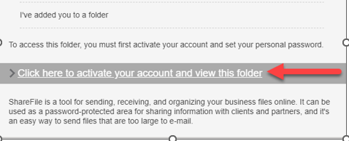

Please use the link provided in this email to activate and set a password.
- Sharefile link: https://widoj.sharefile.com
- Sign in using your email address and password
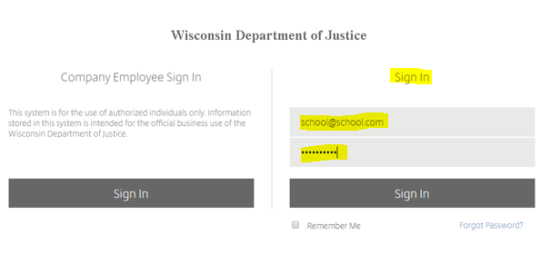
Drag and drop the documents from your computer to the appropriate folders.

