Hello,

The Wisconsin Department of Justice-Office of School Safety Share File procedure to upload the documents required by the 2017 Wisconsin Act 143 are below.  The DOJ-OSS share file has folders within each school’s folder to upload the following documents: blueprints/maps; grant certifications; safety assessments; safety plans; school safety training; threat assessments and violence drills. Grant certifications and threat assessment folders are not currently required under Act 143.

If you have just newly been added to your school’s Sharefile folders, you will need to activate and set up your password.

When you are added to your school’s Sharefile folders, you will receive an email that looks like this:

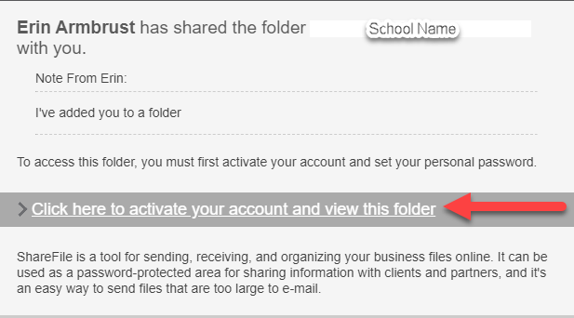

Please use the link provided in this email to activate and set your personal password.

To upload the necessary documents:

1. Go to <https://widoj.sharefile.com>
2. Sign in using your email address and password

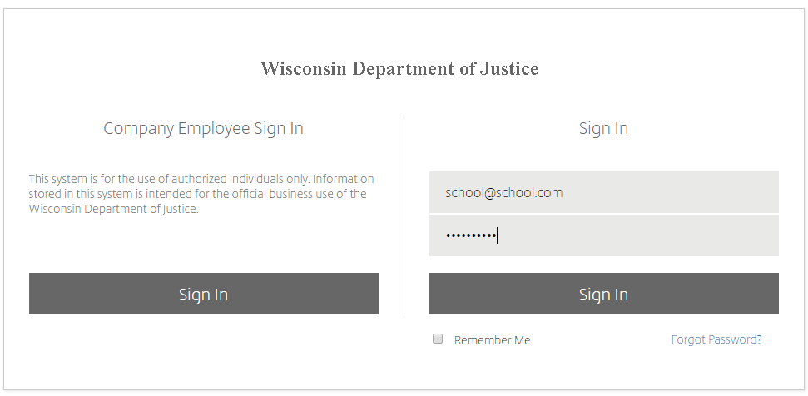

1. Folders shared with you should appear automatically as shown below.

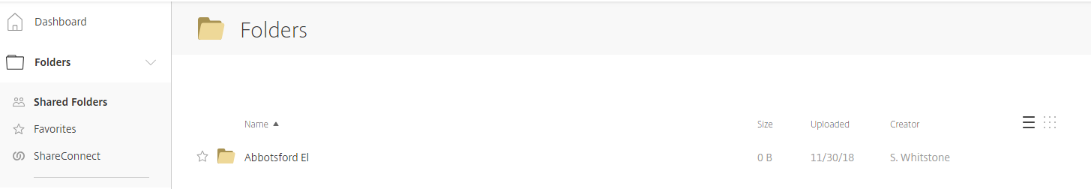

1. Click on the folder (example here being Abbotsford Elementary)
2. The subfolders will show up as shown below. Once you get to the appropriate folder, you can drag and drop files into it.

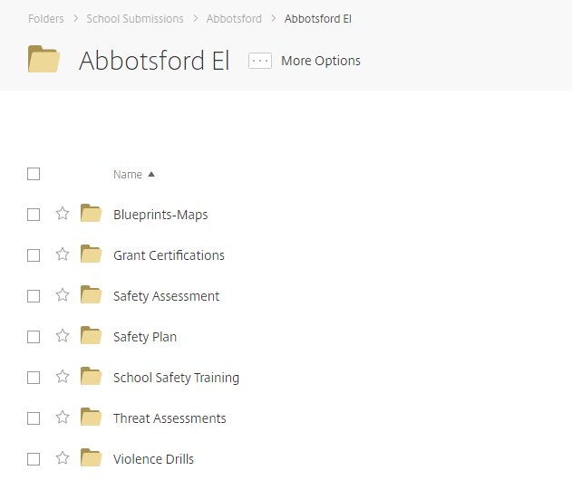

1. As an example, let’s say I’m Abbotsford Elementary and I want to upload Violence Drills for the 2018-2019 school year.
   1. Click on Abbotsford El, and then Violence Drills, and then 2018-2019. Your screen will look like the below.

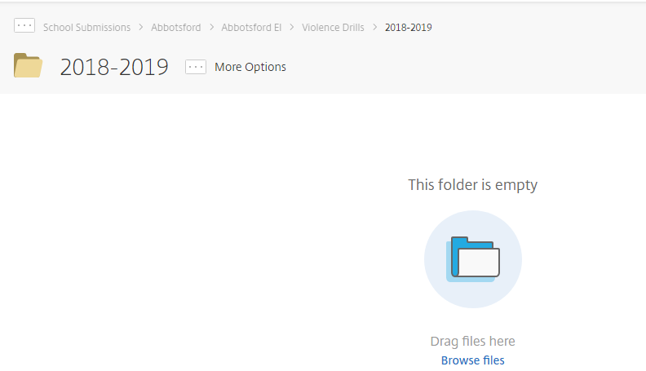

* 1. From there, you can simply drag and drop files in.
  2. You can go back to the main folder using your browser’s “back” button or by clicking the folder names in the bar at the top.

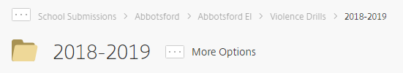

* 1. In the screenshot above, I would click on “Abbotsford El” to get back to the main Abbotsford Elementary folder and go to wherever else I need to upload files.

For further instruction see the OSS website: <https://www.doj.state.wi.us/office-school-safety/office-school-safety>

Please forward all questions to the OSS email:  [schoolsafety@doj.state.wi.us](mailto:schoolsafety@doj.state.wi.us)

Thank you,

The Department of Justice - Office of School Safety