**STATE OF WISCONSIN**

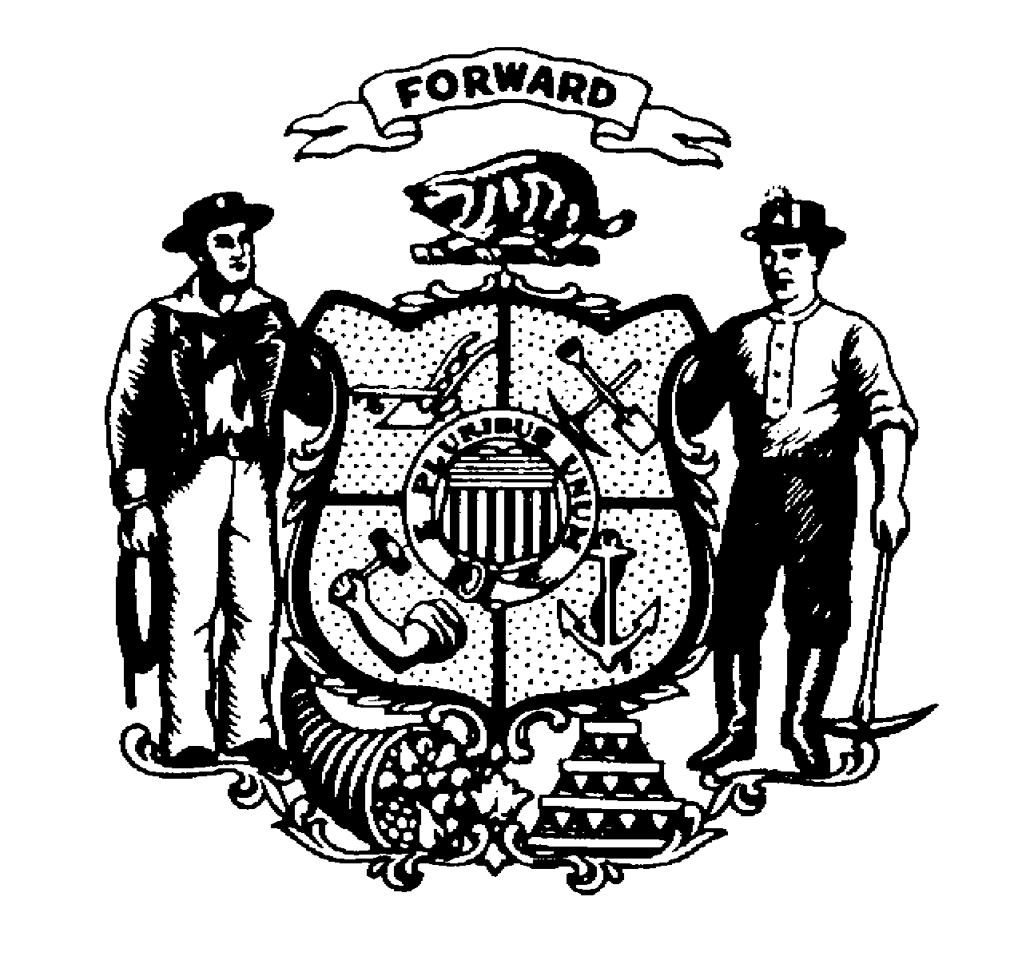

**DEPARTMENT OF JUSTICE**

⎯⎯⎯⎯⎯⎯⎯⎯⎯⎯⎯⎯⎯⎯⎯⎯⎯⎯⎯⎯⎯⎯⎯⎯⎯⎯⎯⎯⎯⎯⎯⎯⎯⎯⎯⎯⎯⎯⎯⎯⎯⎯⎯⎯⎯⎯⎯⎯⎯⎯⎯⎯⎯

# DIVISION OF LAW ENFORCEMENT SERVICES PO Box 2688

## Crime Information Bureau Madison, WI 53701-2688

#### Wisconsin Criminal History

#### Customer Account Application

### Record Check Unit 608/266-5764

##### 

The Wisconsin Department of Justice agrees to furnish criminal history record information as is available from the Crime Information Bureau consistent with the provisions of Wisconsin Statutes 165.82 and 19.35(1). Complete this application to request a customer account for billing record check requests. Account Number:

Click here to enter text.

**Applicant Information:** New Account  Update Account

Name: Click here to enter text. Attn: Click here to enter text.

Street: Click here to enter text. Phone: Click here to enter text.

FAX: Click here to enter text.

City, State,

Zip: Click here to enter text. E-mail: Click here to enter text.

###### Requestor Type – Check One Billing Address (if different than above):

Government Agency

General Public

Nonprofit Org. Click here to enter text.

[Nonprofit account application must include a copy of 501(c)3

determination letter from the Internal Revenue Service]

Daycare Facility,

Yes:  No:  If yes, include Facility ID: Click here to enter text.

Regulations for account customers with the Crime Information Bureau:

1. This agreement remains in effect until terminated in writing by the Wisconsin Department of Justice or the requestor.
2. The Crime Information Bureau will prepare and send an invoice by the 15th of the month for record checks requested in the preceding month.
3. All invoices are due and payable to the Department of Justice within 30 days from the date of the invoice.
4. The Department of Justice may cancel this customer account agreement for nonpayment.
5. The individual signing on behalf of the requesting agency certifies by his or her signature that he or she is authorized to sign this document on behalf of the requestor and such requestor will adhere to all terms of the agreement.
6. Account numbers will be required on all request forms and payments submitted.
7. Non-profit and governmental agencies may not disseminate or re-sell criminal record information obtained at the cost less than general public inquiry fee. Those records may only be used by the government or non-profit agency for its own business purposes.

Mail application to: Attn: Record Check Unit Click here to enter text. Click here to enter a date.

17 West Main Street **(*Authorized signature) (Date)***

PO Box 2688

Madison, WI 53701-2688 Click here to enter text.

FAX application to: (608) 267-4558 ***(Title)***